Lab Assignment 8
- (Username Validator – Apply AI in Authentication Context) Task:
Use AI to generate at least 3 assert test cases for a function is_valid_username(username) and then implement the function using Test-Driven Development principles.
Requirements:
  - Username length must be between 5 and 15 characters.
  - Must contain only alphabets and digits.
  - Must not start with a digit.
  - No spaces allowed. Example Assert Test Cases:
  - assert is_valid_username("User123") == True
  - assert is_valid_username("12User") == False
  - assert is_valid_username("Us er") == False Expected Output:
  - Username validation logic successfully passing all AI-generated test cases.

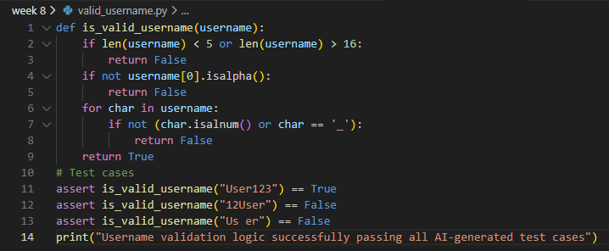

Output:

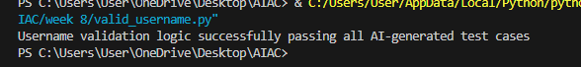

- (Even–Odd & Type Classification – Apply AI for Robust Input Handling) Task:
Use AI to generate at least 3 assert test cases for a function classify_value(x) and implement it using conditional logic and loops.
Requirements:
  - If input is an integer, classify as "Even" or "Odd".
  - If input is 0, return "Zero".
  - If input is non-numeric, return "Invalid Input”. Example Assert Test Cases:
  - assert classify_value(8) == "Even"
  - assert classifassert classify_value("abc") == "Invalid Input"
  - Expected Output
● assert classify_value("abc") == "Invalid Input"
Expected Output:
● Function correctly classifying values and passing all test cases
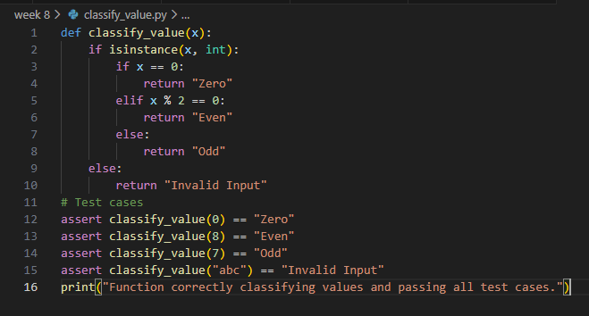

Output

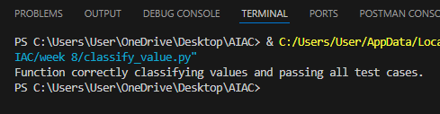

- (Palindrome Checker – Apply AI for String Normalization) Task:
Use AI to generate at least 3 assert test cases for a function is_palindrome(text) and implement the function.
Requirements:
  - Ignore case, spaces, and punctuation.
  - Handle edge cases such as empty strings and single characters. Example Assert Test Cases:
  - assert is_palindrome("Madam") == True
  - assert is_palindrome("A man a plan a canal Panama") == True
  - assert is_palindrome("Python") = False
  - Expected Output #3:
  - Function correctly identifying palindromes and passing all AI-generated tests.

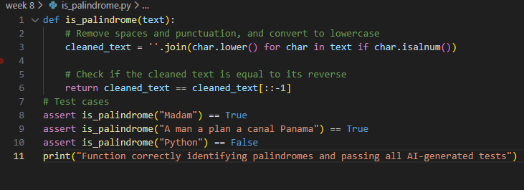

Output:

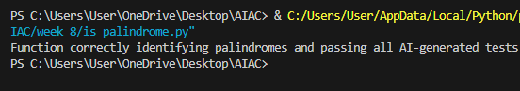

- (Email ID Validation – Apply AI for Data Validation) Task:
Use AI to generate at least 3 assert test cases for a function validate_email(email) and implement the function.
Requirements:
  - Must contain @ and .
  - Must not start or end with special characters.
  - Should handle invalid formats gracefully. Example Assert Test Cases:
  - assert validate_email("user@example.com") == True
  - assert validate_email("userexample.com") == False
  - assert validate_email("@gmail.com") == False
  - Expected Output #4:
  - Email validation function passing all AI-generated test cases and handling edge cases correctly.
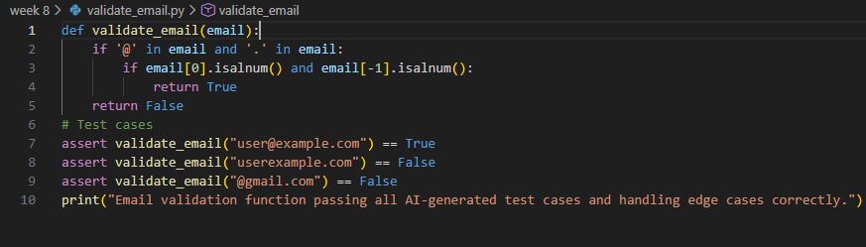

Output:
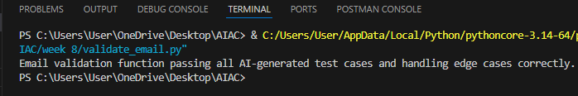

- (Perfect Number Checker – Test Case Design) Function:
Check if a number is a perfect number (sum of divisors = number). Test Cases to Design:
  - Normal case: 6 → True, 10 → False.
  - Edge case: 1.
  - Negative number case.
  - Larger case: 28. Requirement:
  - 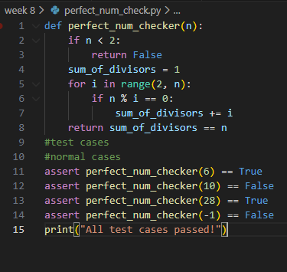
  - Output:
  - 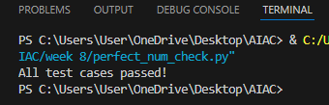

- (Abundant Number Checker – Test Case Design) Function:
Check if a number is abundant (sum of divisors > number). Test Cases to Design:
  - Normal case: 12 → True, 15 → False.
  - Edge case: 1.
  - Negative number case.
  - Large case:945. Requirement:
Validate correctness with unittest
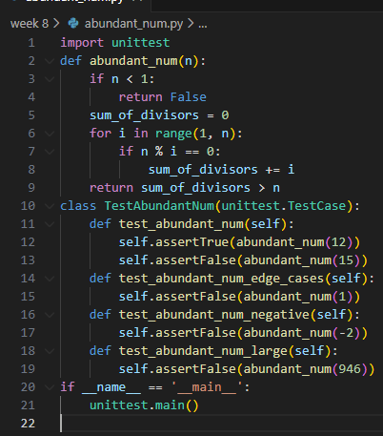
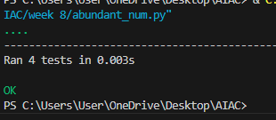
- (Deficient Number Checker – Test Case Design) Function:
Check if a number is deficient (sum of divisors < number). Test Cases to Design:
  - Normal case: 8 → True, 12 → False.
  - Edge case: 1.
  - Negative number case.
  - Large case:546. Requirement:
Validate correctness with pytest.
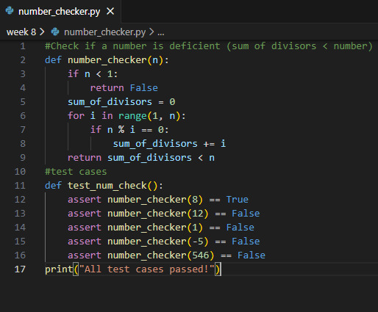
Output:

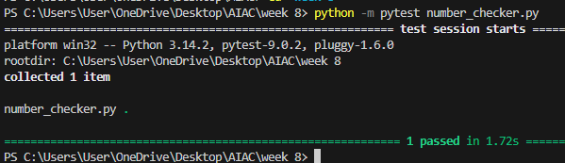

- Write a function LeapYearChecker and validate its implementation using 10 pytest test cases.
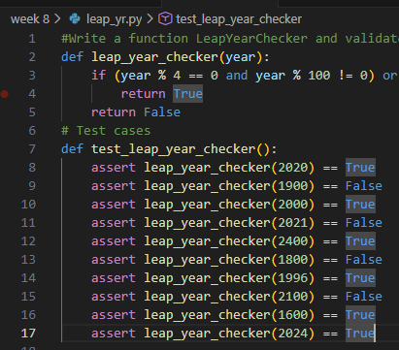
Output:
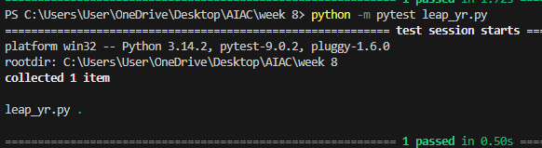

- Write a function SumOfDigits and validate its implementation using 7 pytest test cases.
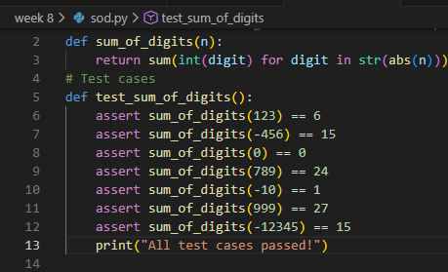
Output:
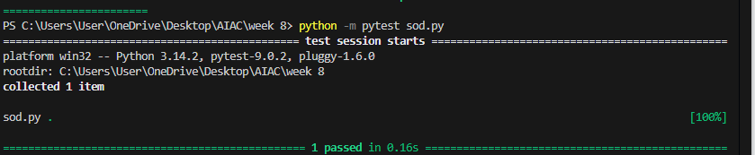

- Write a function SortNumbers (implement bubble sort) and validate its implementation using 25 pytest test cases.
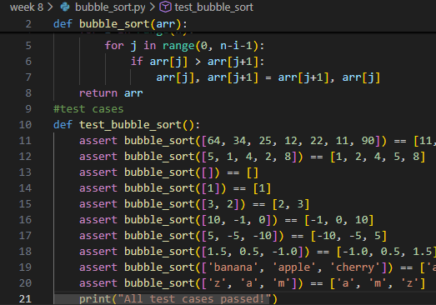
Output:
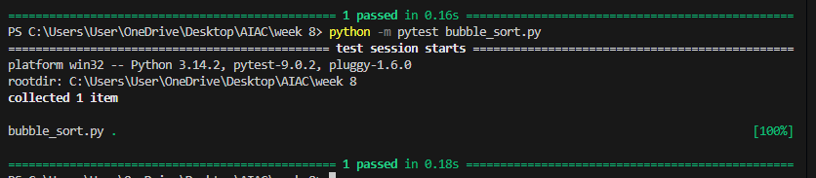

- Write a function ReverseString and validate its implementation using 5 unittest test cases.

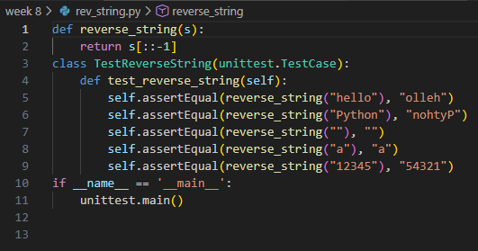
Output:
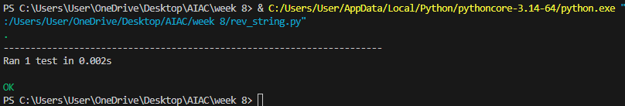
- Write a function AnagramChecker and validate its implementation using 10 unittest test cases.
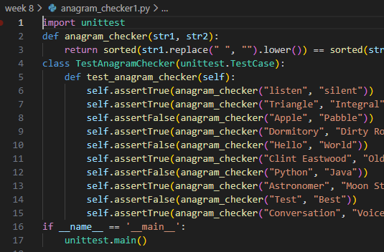

Output:
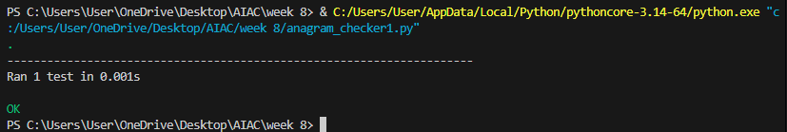

- Write a function ArmstrongChecker and validate its implementation using 8 unittest test cases
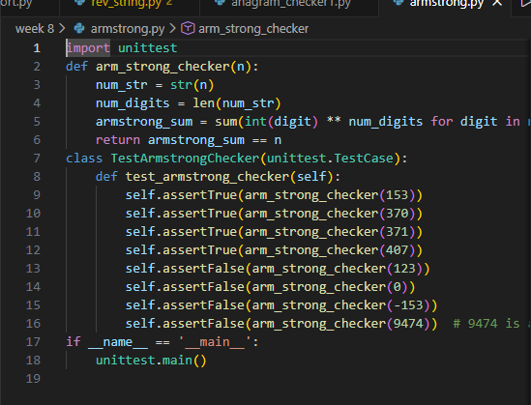

Output:
